Name:

Required Rehearsals
Side Show will involve rehearsals for music, choreography, and blocking. A schedule of rehearsals will be provided to all cast members. Please carefully fill out the conflict information on the back of this form and review all information in this section for required, no conflict dates.
- Initial to confirm that you do not have any conflicts Apr. 16-20:
- Initial to confirm that you do not have any conflicts Apr. 22-Apr. 27:
- Initial to confirm that you do not have any conflicts for the performance dates of Apr. 28-30, May 5-7, and May 11-14:

Rehearsal Conflicts – Additional Details
Cast are expected to attend all rehearsals as scheduled. Please provide as much detail as possible for any potential conflicts during the rehearsal timeframe. We are aware that emergent issues may arise and those will be considered excused absences. However, three or more unplanned absences may result in removal from the cast.

Rehearsals are tentatively scheduled for Sundays from 1:00 – 4:00 pm and Tuesdays, Wednesdays, and Thursdays from 6:00-9:00 until the week before tech.

Please list below any conflicts that you have, providing as much detail as possible including days, dates, and times unavailable. For example, if you have a standing commitment on Tuesdays from 6:00-7:00 pm, please indicate that you are only available on Tuesdays after 7:30.

X = No conflicts allowed
These dates reflect the week before tech, sitzprobe, the week of tech, and all performances. If you have a conflict on any of these days, please speak with the Stage Manager prior to auditioning.

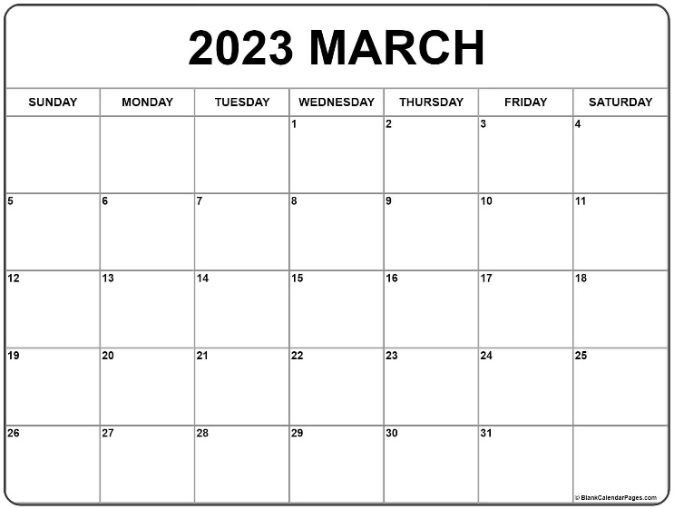
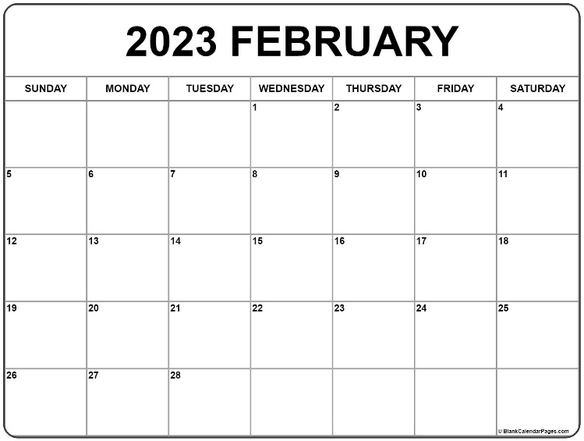

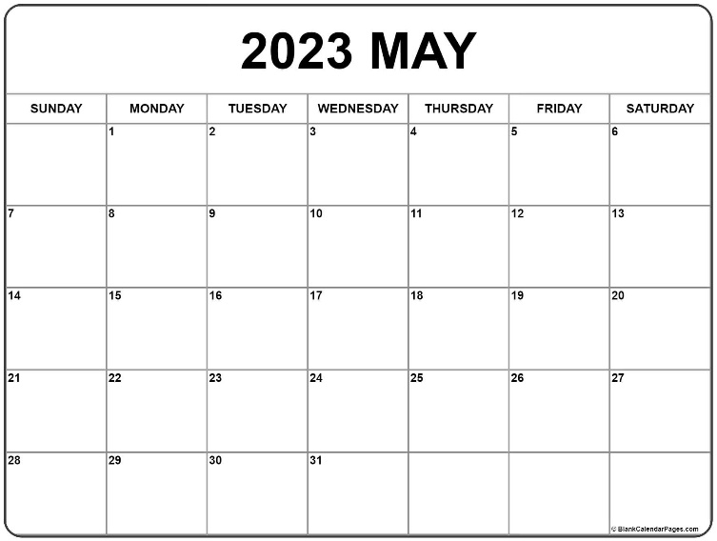
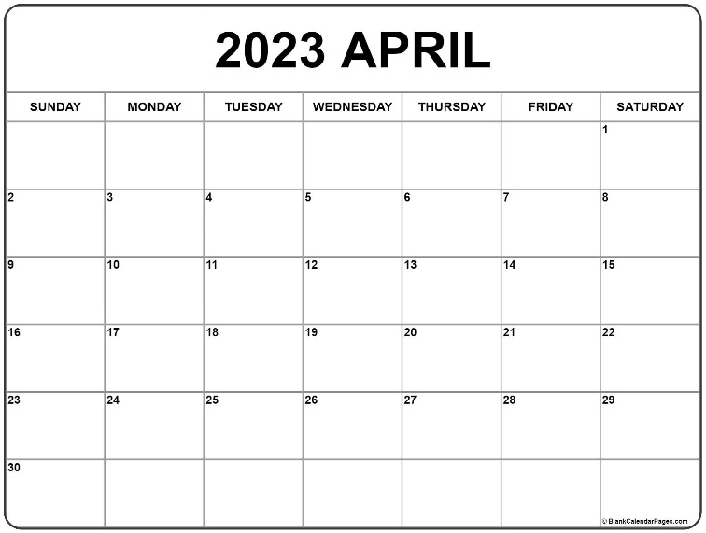
X
X
X
X
X
X
X
X
X
X
X
X
X
X
X
X
X
X
X
X
X

